<https://youtu.be/KLj6UGZBUNI?si=CyG_5FTjBfDgPdry>

For this assignment, you will create a tutorial with directions on how to embed a service-hosted video into a website. Each step of your directions should be accompanied by a screenshot that demonstrates the step. Crop your screenshots to focus only on where the action is being taken—do not include images of entire desktop screenshots for each step.

<video width="320px" height="240px" preload="auto" controls>

<source src="file.mp4" type="video/mpeg" />

<source src="file.ogg" type="video/ogg" />

This browser does not support this video.

</video>

1st - Choose the height and width of your video - this is not a feature for audio tags however it is a fatal part of the video tag.

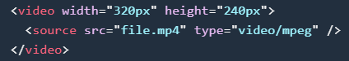

2nd—Choose what type of preload value you would like. How would you like it to download when it starts?

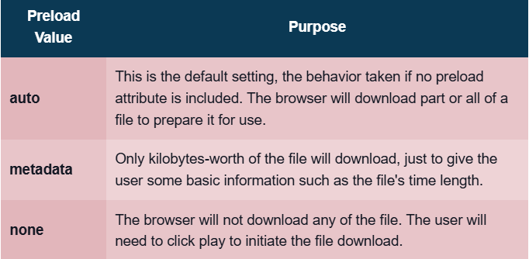

<video width="320px" height="240px" preload="auto" controls>

<source src="file.mp4" type="video/mpeg" />

<source src="file.ogg" type="video/ogg" />

This browser does not support this video.

</video>

3rd - Choose your Boolean - What will happen when the video appears

Autoplay will start the video automatically when it is downloaded enough.

Controls - Shows the control buttons such as play, pause, volume, and adjustment.

Loop - The video will restart after it reaches the end.

Muted - It will initially start muted.

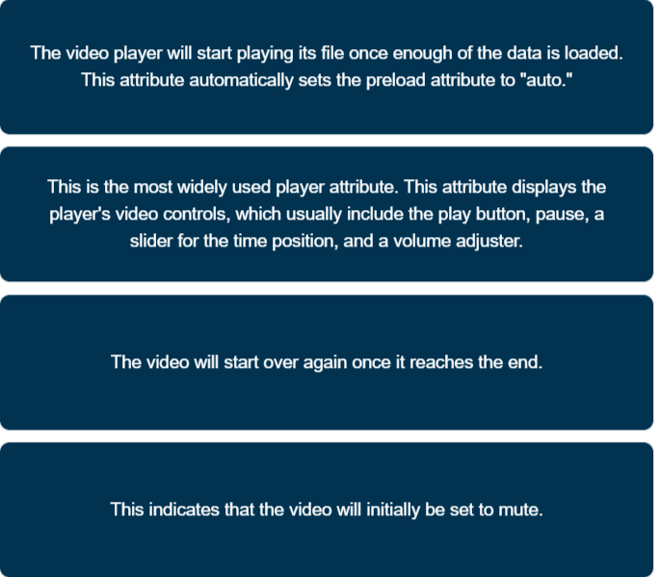

<video width="320px" height="240px" preload="auto" controls>

<source src="file.mp4" type="video/mpeg" />

<source src="file.ogg" type="video/ogg" />

This browser does not support this video.

</video>

4th - Depending on the file you will decide which file type you would like to use.

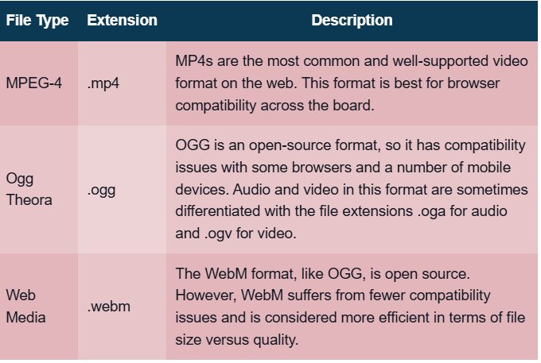

<video width="320px" height="240px" preload="auto" controls>

<source src="file.mp4" type="video/mpeg" />

<source src="file.ogg" type="video/ogg" />

<source src="file.webm" type="video/webm" />

This browser does not support this video.

</video>

5th - <iframe> contains a window which displays content from another source such as documents, forms, or other websites

Example :

<iframe width="560" height="315" src="https://www.youtube.com/embed/KLj6UGZBUNI?si=6XCa0Bb3BqPpv2Ax" title="YouTube video player" frameborder="0" autoplay></iframe>

[Solve the Mystery in 12 Riddles with a Fun Twist](https://youtu.be/KLj6UGZBUNI?si=CyG_5FTjBfDgPdry)